1. Login screen |It should be “Please enter your Email/Username and Password”.

Also When put incorrect email system should be show validation error that should be “Invalid email username or password”.

One is suggestion – Field lable name should be same e.g there is showing “Email” but above is displaying username, its must be same.

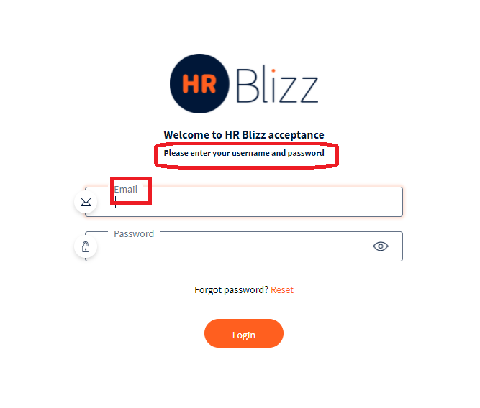

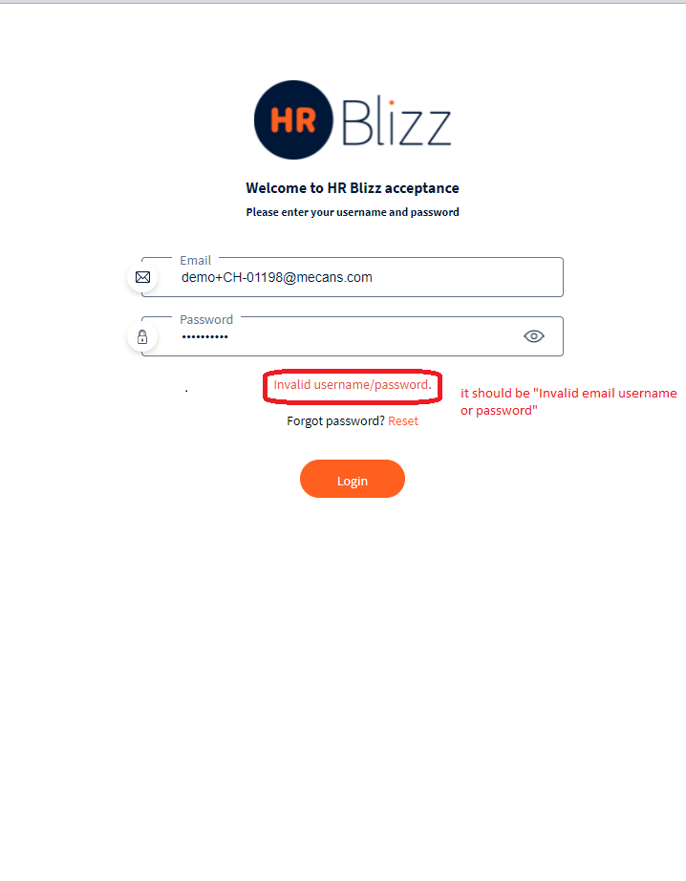

1. My Information – Profile Picture | When user update profile picture, application is not displaying the updated profile picture even the page is reload. See below screenshot

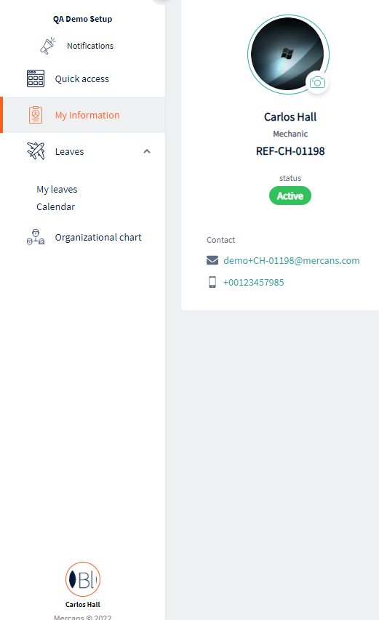

1. My Information – Profile Picture | When updated picture is deleted, application still displaying the last update picture even user redirection on any other page.

See below screenshot

Expected : System should be delete and update picture in whole application.

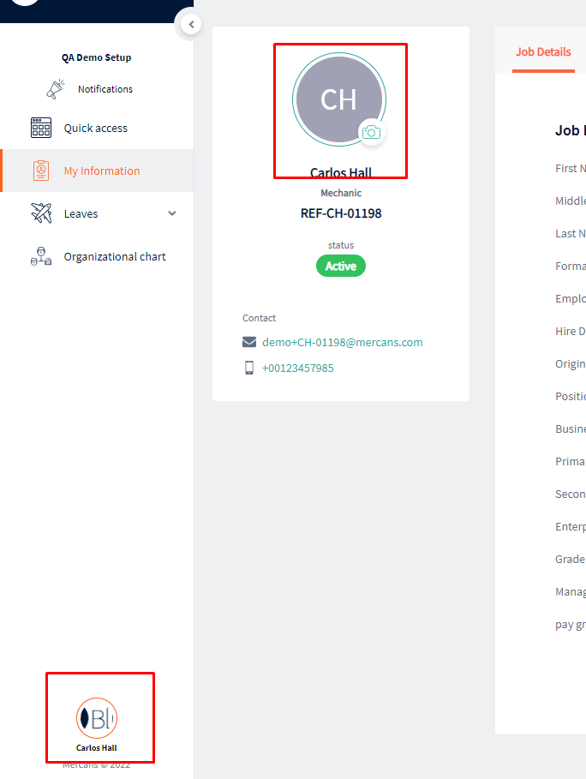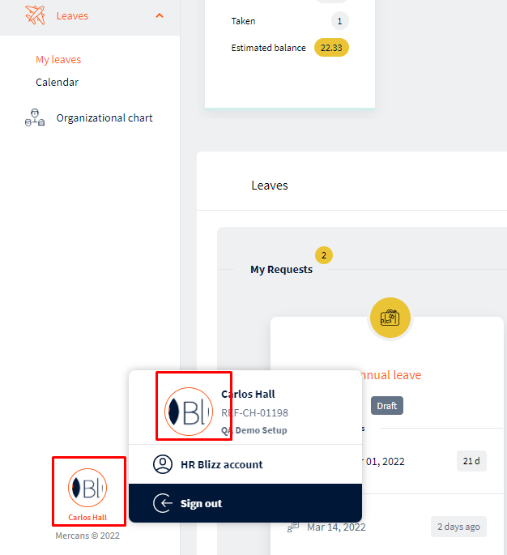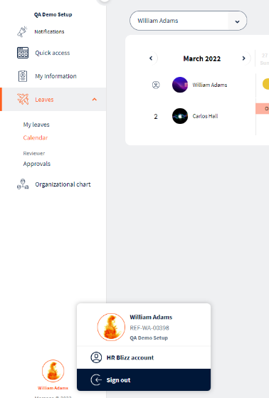

1. My Information – Job Details | The “Edit” link is not working.

when mouse hover to edit link it showing “There are no editable fields”, If there are not any editable field then remove this Edit link but this is my information page, if there is not any edit/update link, user not be able to do or update any information.

( Suggest ) There should be a Edit link and this Edit link should be working perfectly.

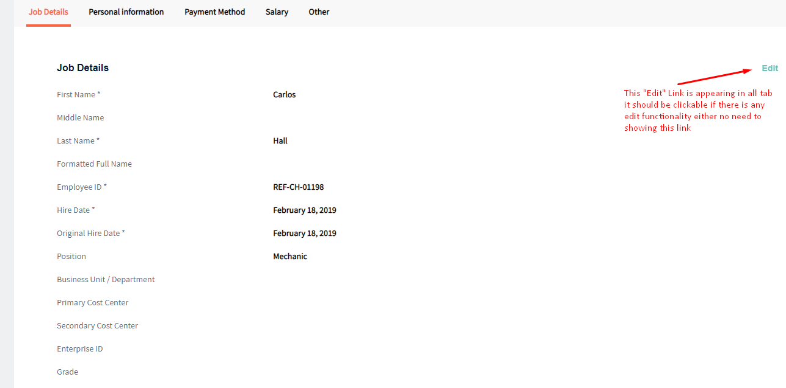

1. My Infromation – Salary | There’s a link “view more”, when click on view more link nothing action was performed, Also the alignment of link is incorrect. See below screenshot

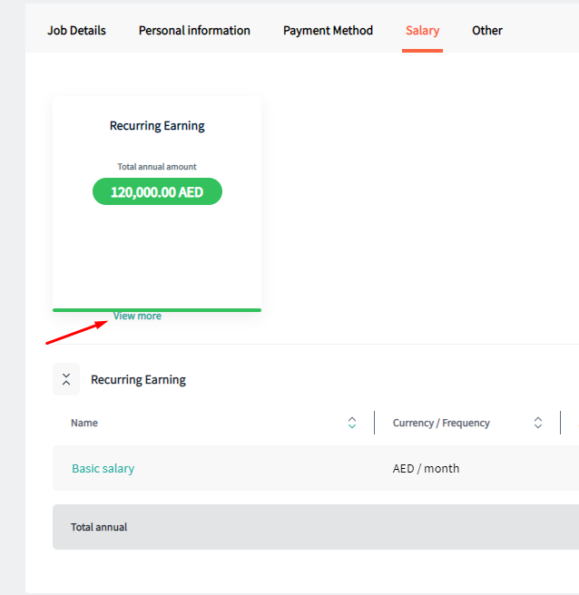

1. My Information – Salary | The scrolling bar should not be display in Recurring Earning grid.

Only six colomns in grid, No need to displaying scrolling.

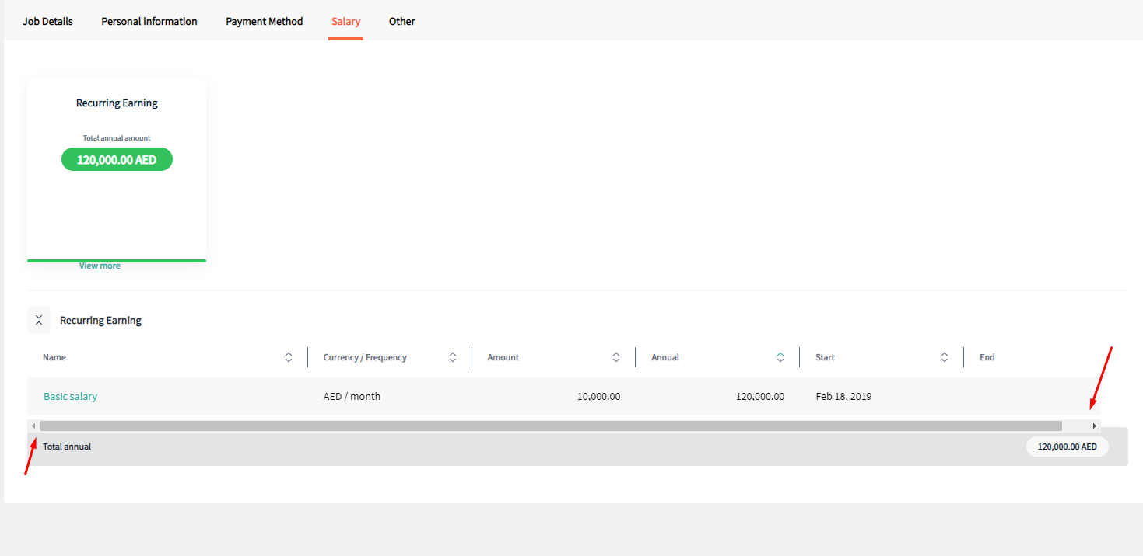

1. Leaves – My Leaves – Request New Leave | The format of file/documents are should be define.

Currently: Application is accepting any type of format file.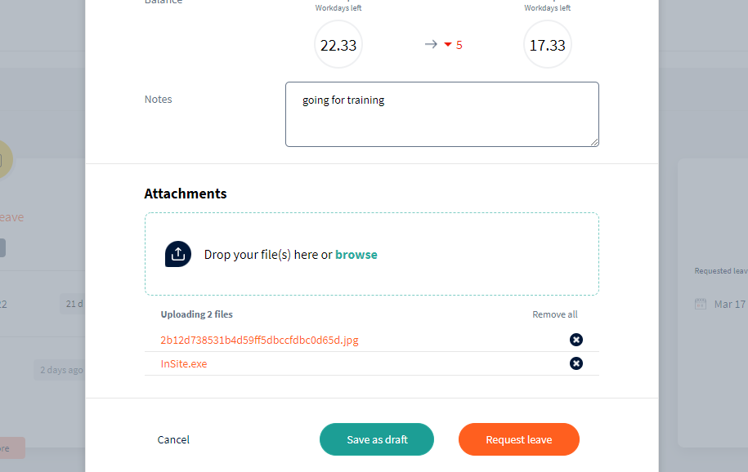

1. Leaves – My Leaves – Request New Leaves | The uploading file limition should be applied in attachments.

Currently there are no any limition in uploading files section, application are accepted as many files.

Expected: Application should store number of 10 files, if number of stored files count greater than 10 application should be show validation error message.

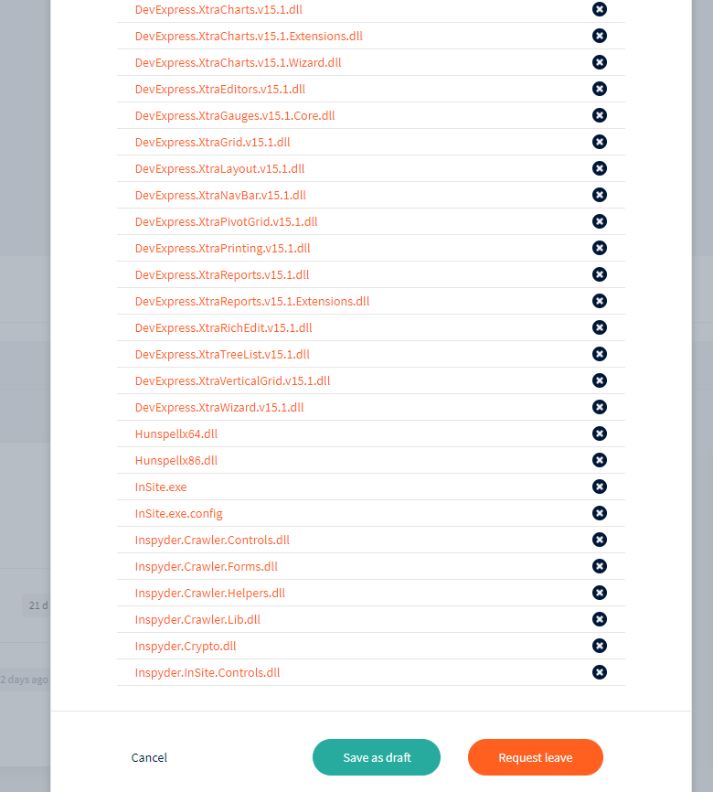

1. Leaves – My Leaves – Request New Leaves | Application should not allowed file size larger than 25MB. If uploading file size greater than 25MB then application must be showing error message “File Size Limit Exceeded”.

Currently: Application storing and submitting request any size of file.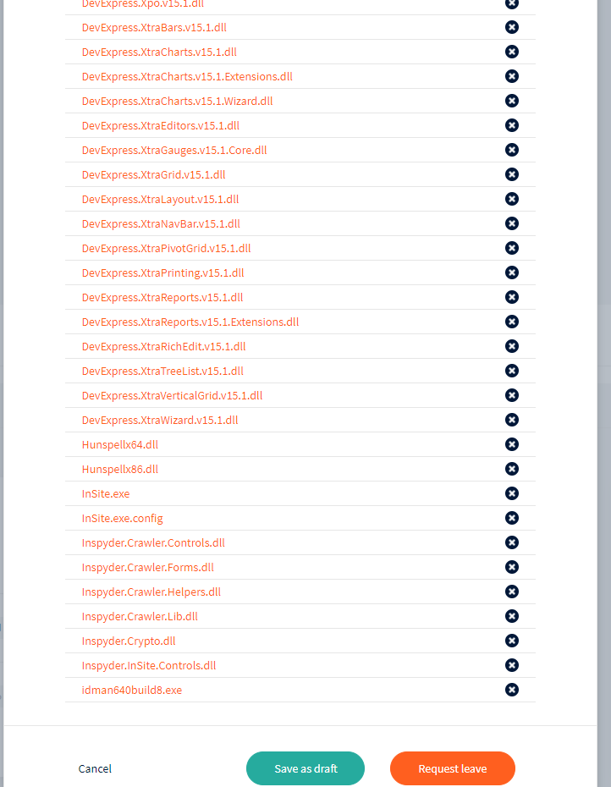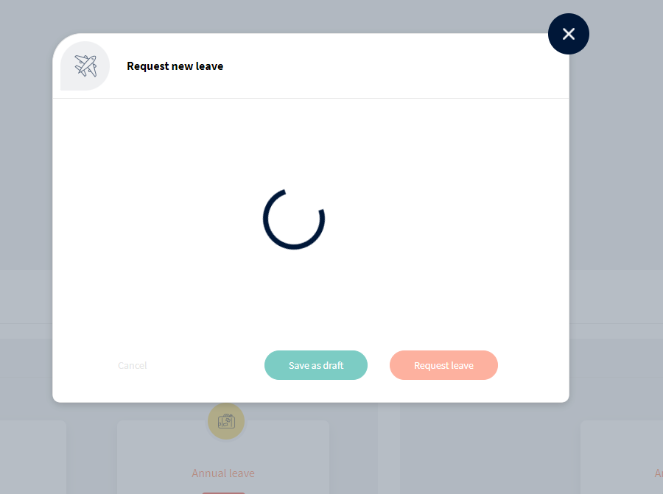

1. Notification | The Notification panel is complete not working.

Application should be showing those notifications request which are come to approvel and any other type of notification.

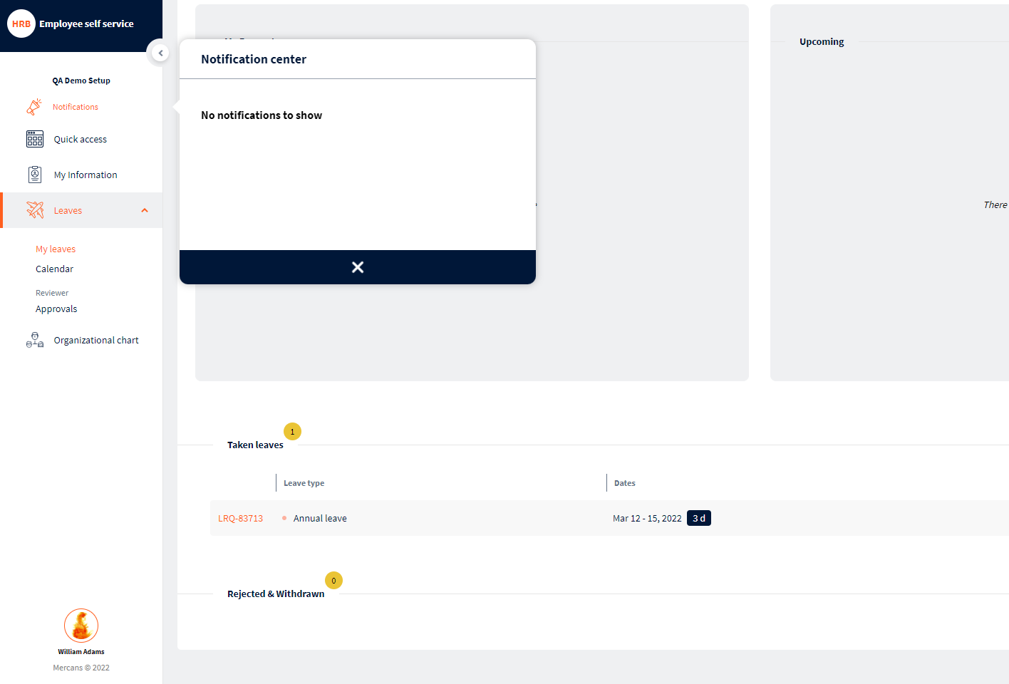

1. Menu Panel, Headings and whole App | The Font and font size should be same and proper standard to WCAG 2 .

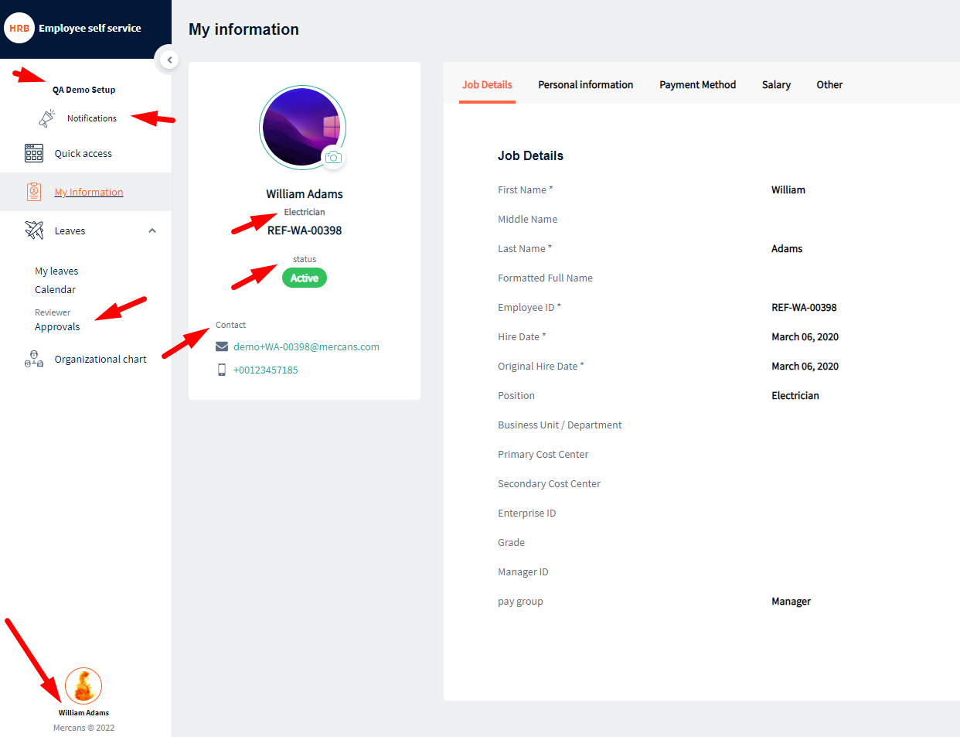

1. Leave – My Leave – Request New Leave| The application should be restrict past date.

Many issues are come Due to past date selectable

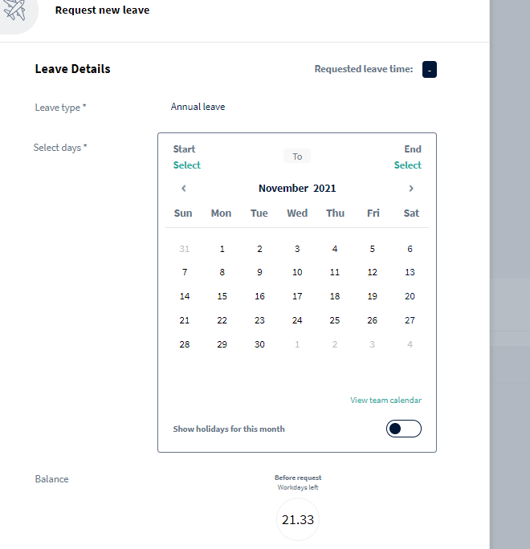

1. Leave – My Leaves | Incorrect status is displaying due to overlap leaves.

Manager approval screen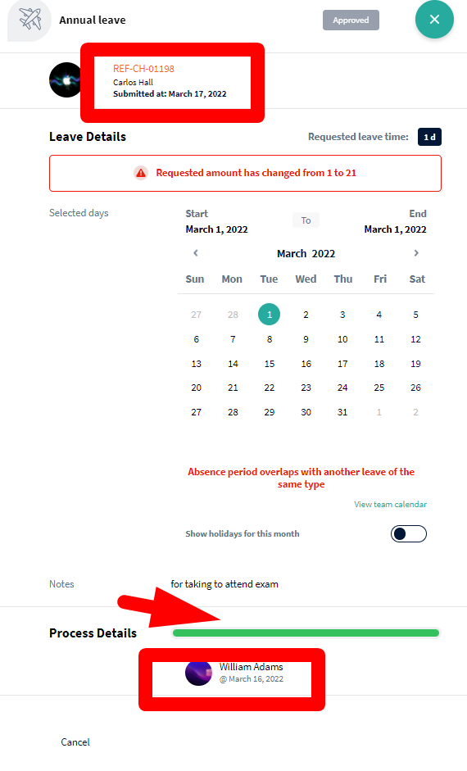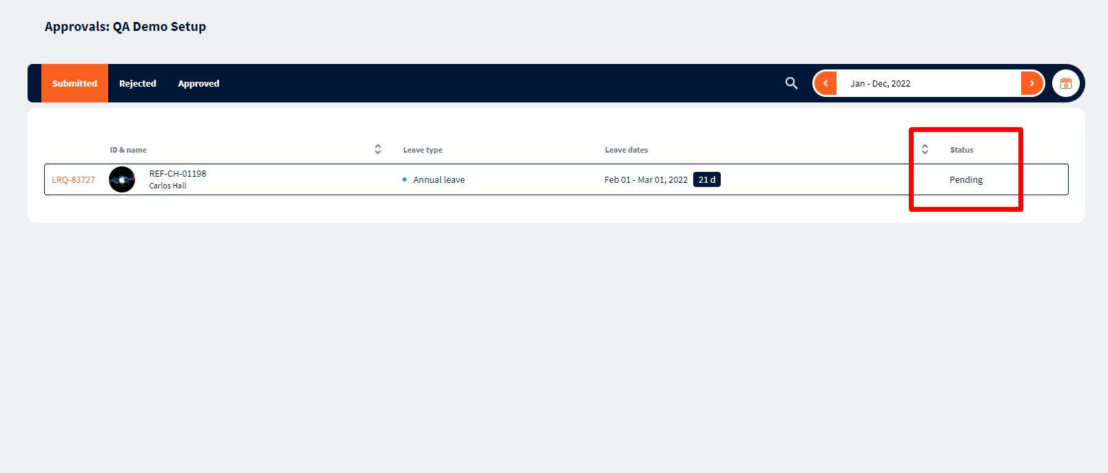

1. Leave – My Leave | Leave panal are not working perfectly.

Annual Leave count calculation are smash

Taken leaves count calculation are displaying wrong

Rejected & withdrawn count calculation are not working

Case: When past date leaves are overlaping user create a new request leave which are mark in save draft.

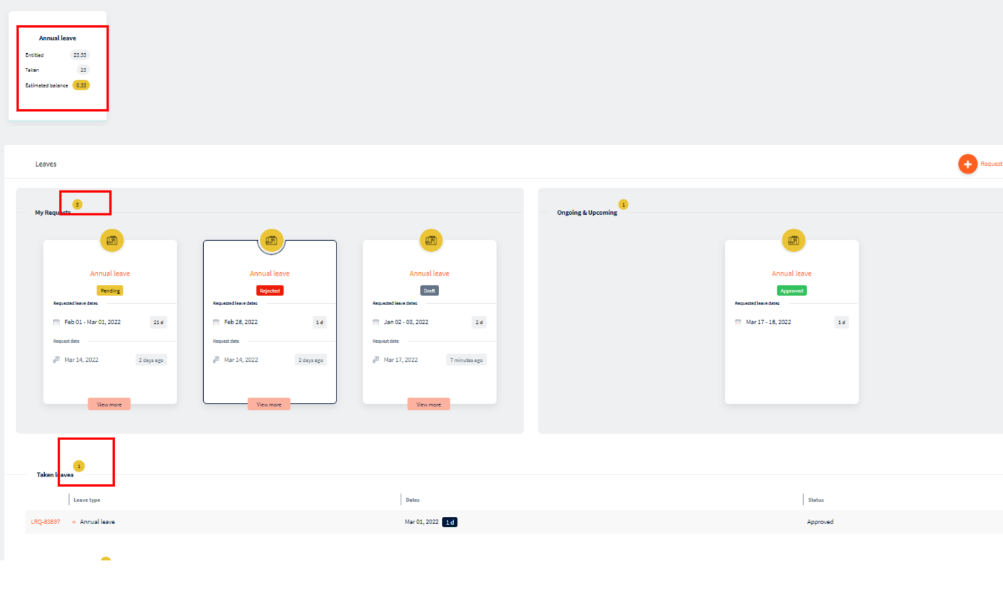

1. Calander and My Leave | The approved button color is not displaying.

When click on leave link one by one, the status button color is not picking.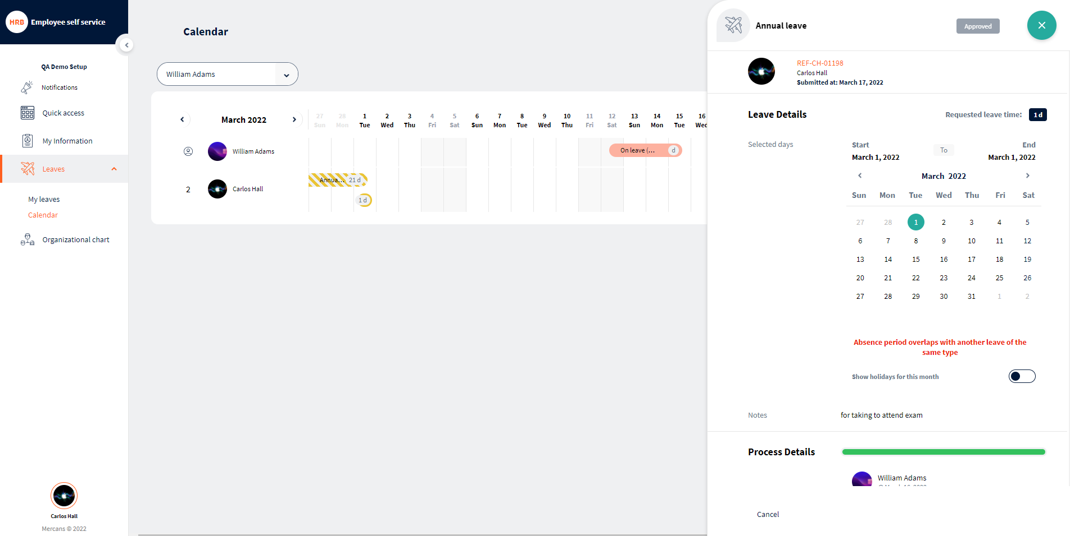

1. Calander – Annual Leave Pop up screen | Incorrect request leave time is showing

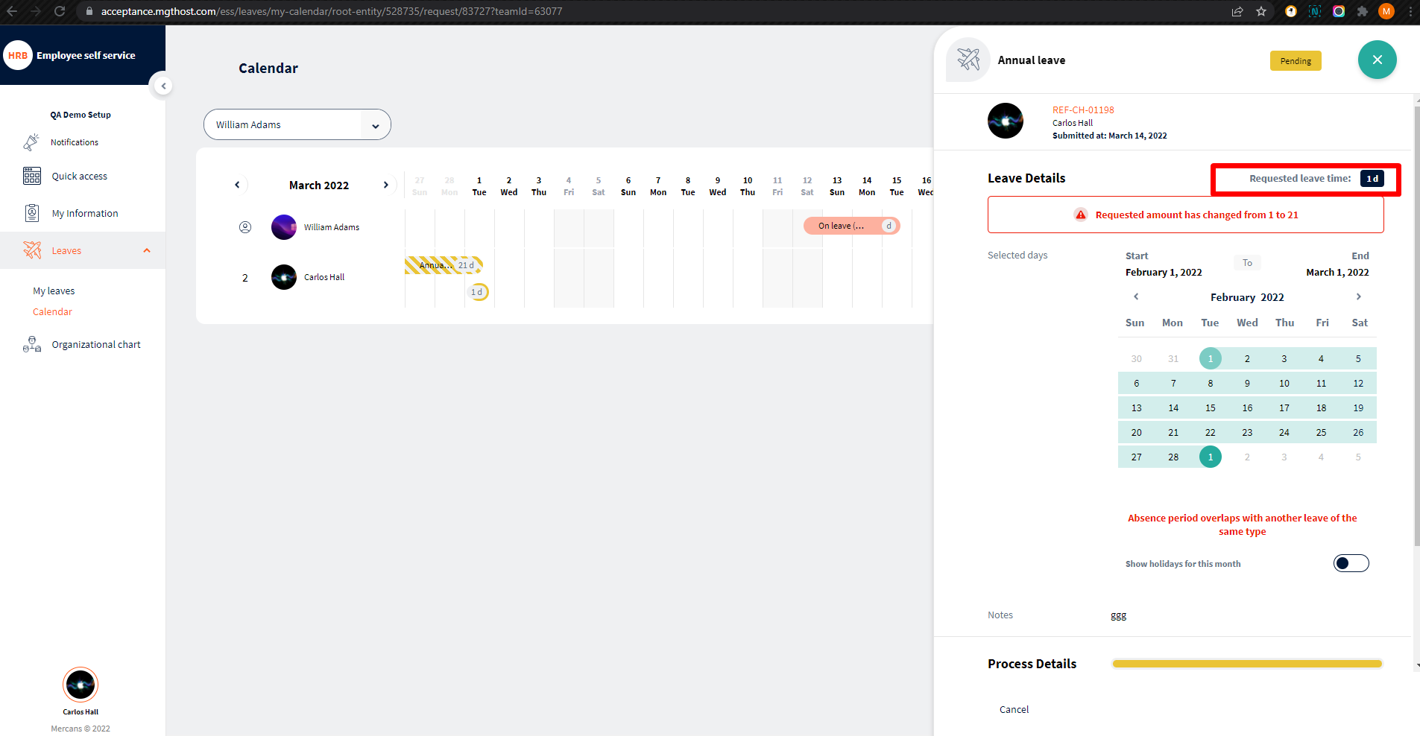

1. Leave – My Leave | Couple of same record are added in My request panel section.

When user save to draft one time then make some changes in leave request and again click on save to draft button. Application added same request leave couple of time.

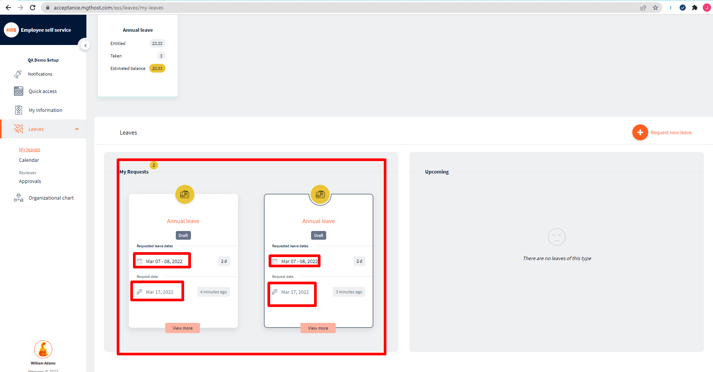

1. Leave – My Leave – Request New Leave | Requst new leave is not added to draft in run time.

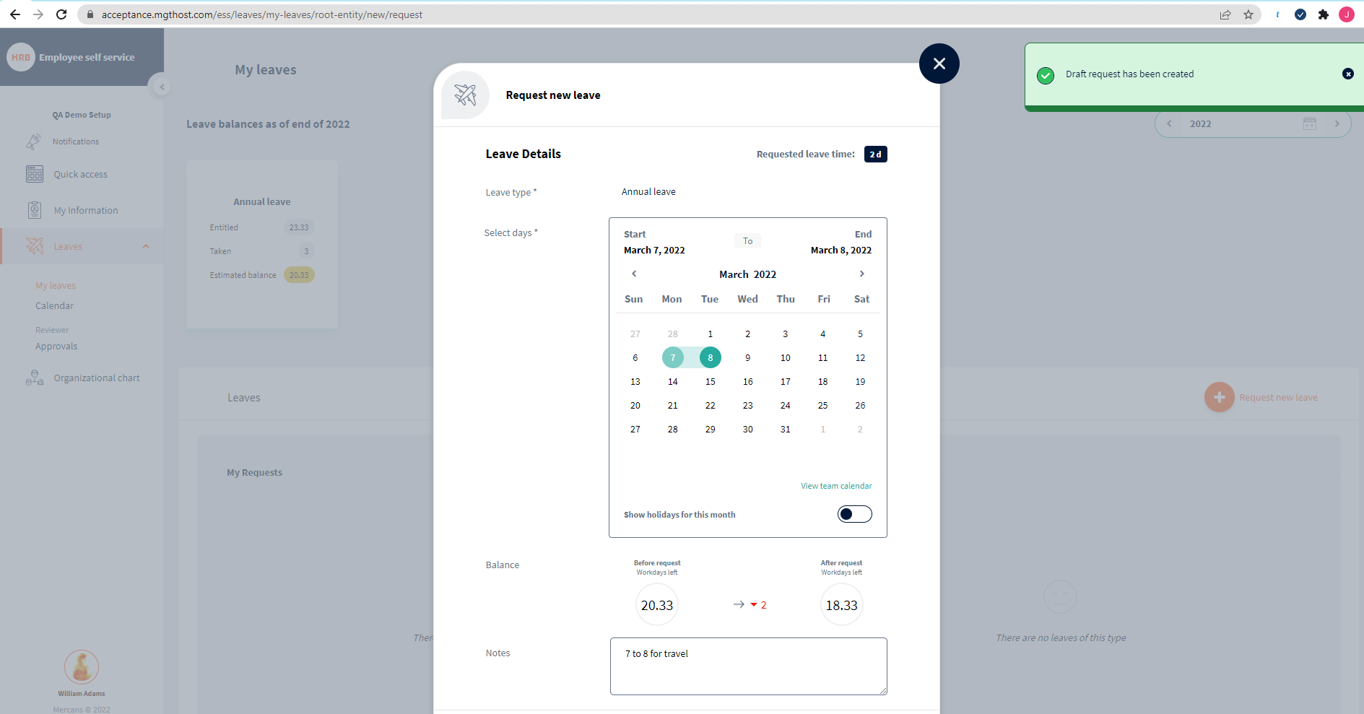

1. Leave – My request | Incorrect status is displaying on My request panel

When manager request new leave is mark to save draft then submitted request leave, application is displaying that leave still in draft even its auto aprroved

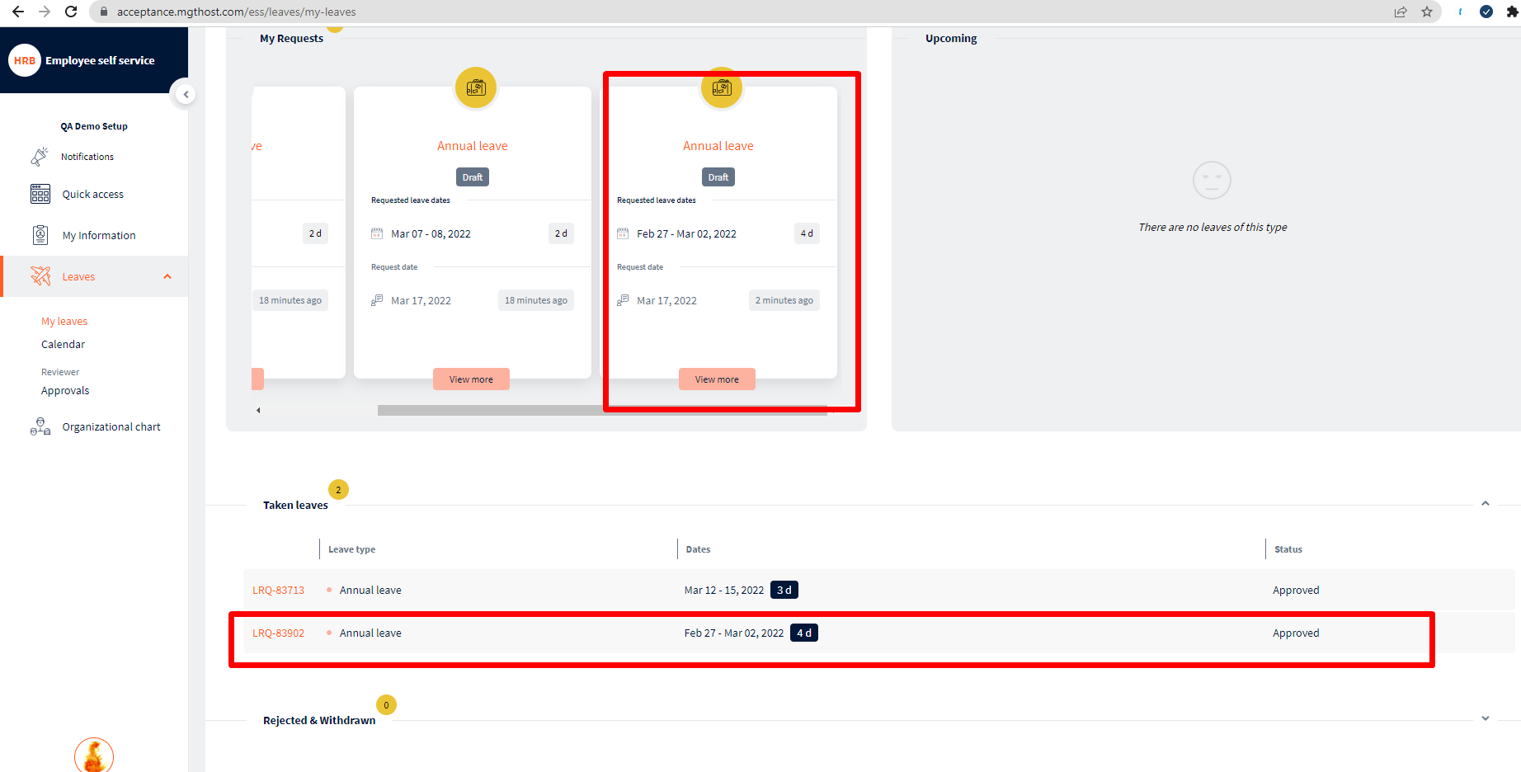

1. Leave – My Leave – Annual Leave | Incorrect number of count calculation are appearing.
2. Two Factor Authentication – SMS | Invalid phone number should not be accepted 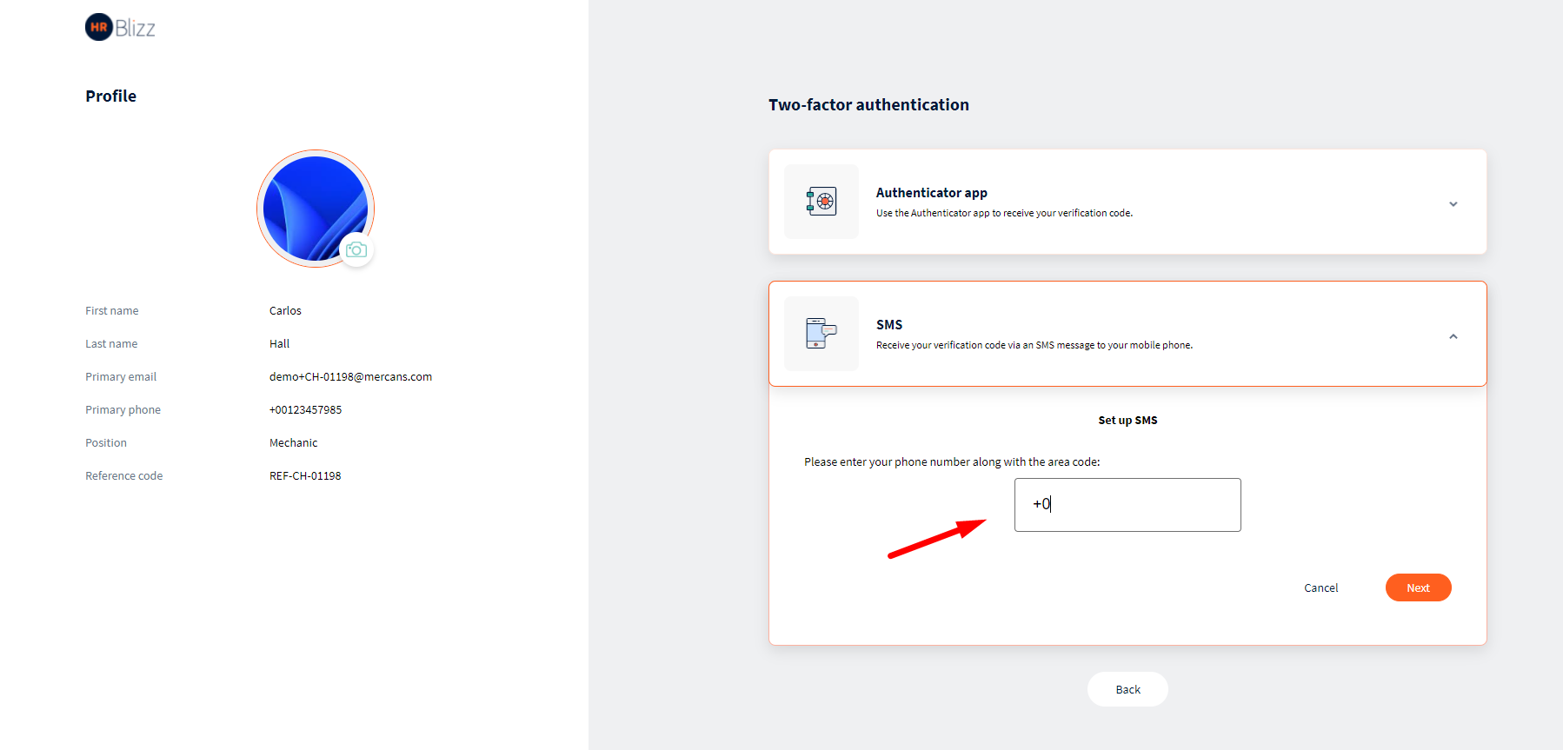
3. Two Factor Authentication – SMS |No any SMS code is not received to a valid number
4. Leave – My Leave – Request new Leave | Some time the request new leave is not submitting, when user click on request leave button, the application is freeze and continuously loading

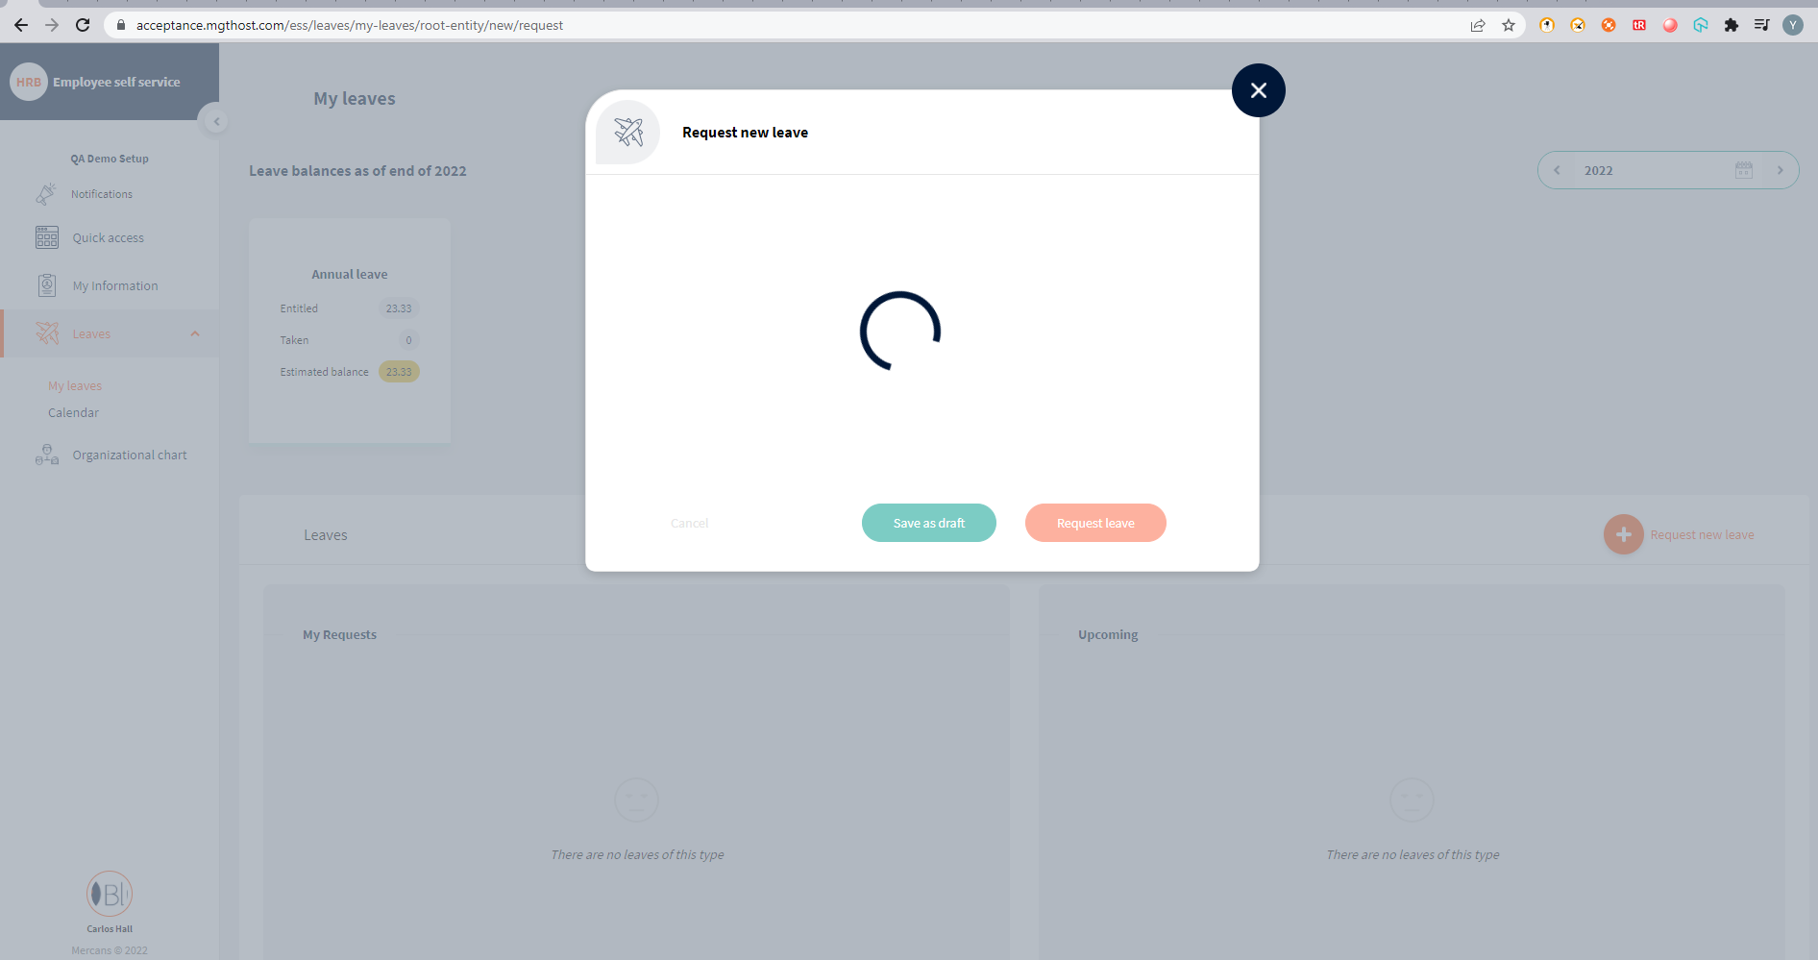

1. Leave – My Leave – Taken Leave |The modifying functionality is not working correct, When manager modify our leave and submitted, application defined modify submitted request.

The leave all data are smash and displaying mixing information

